Question1:
#include <stdio.h>
int main() {
int n, search, num, i, found = 0;
printf("Enter the number of elements: ");
scanf("%d", &n);
printf("Enter the element to search: ");
scanf("%d", &search);
for(i = 1; i <= n; i++) {
printf("Enter element %d: ", i);
scanf("%d", &num);
if(num == search) {
found = 1;
printf("Element %d found at position %d.\n", search, i);
break;}
}
if(!found) {
printf("Element %d not found.\n", search);
}return 0;
}

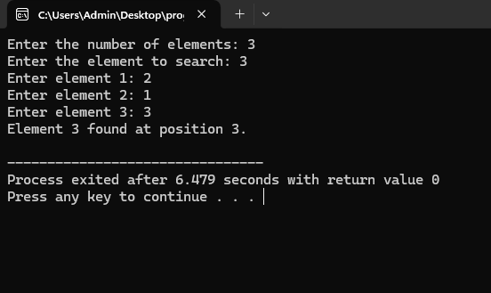

Question2:
#include <stdio.h>
int main() {
int n, i;
int num;
int largest, smallest;
printf("Enter the number of integers you want to compare: ");
scanf("%d", &n);
if (n <= 0) {
printf("Please enter a positive number of integers.\n");
return 1;
}
printf("Enter integer 1: ");
scanf("%d", &num);
largest = num;
smallest = num;
for (i = 2; i <= n; i++) {
printf("Enter integer %d: ", i);
scanf("%d", &num);
if (num > largest) {
largest = num;
}
if (num < smallest) {
smallest = num;
}
}
printf("\nThe largest element is: %d\n", largest);
printf("The smallest element is: %d\n", smallest);
return 0;
}

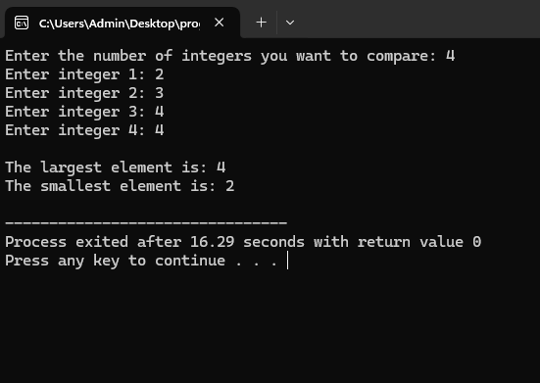
Question3:
#include <stdio.h>
int main() {
int sum = 0;
for (int i = 1001; i < 2000; i++) {
if (i % 3 == 0) {
sum += i;
}
}
printf("the sum = %d\n", sum);
return 0;
}
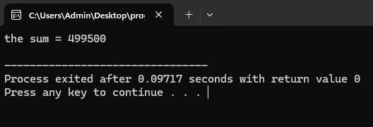

Question4:
#include <stdio.h>
int main() {
int choice;
int num1, num2, result;
do {
// Display menu
printf("\nMenu:\n");
printf("1. Addition\n");
printf("2. Subtraction\n");
printf("3. Multiplication\n");
printf("4. Division\n");
printf("5. Exit\n");
printf("Enter your choice (1-5): ");
scanf("%d", &choice);
if (choice != 5) {
printf("Enter two numbers: ");
scanf("%d %d", &num1, &num2);
}

switch (choice) {
case 1:
result = num1 + num2;
printf("Result: %d\n", result);
break;
case 2:
result = num1 - num2;
printf("Result: %d\n", result);
break;
case 3:
result = num1 * num2;
printf("Result: %d\n", result);
break;
case 4:
if (num2 != 0) {
result = num1 / num2;
printf("Result: %d\n", result);
} else {
printf("Error: Division by zero is not allowed.\n");
}
break;
case 5:
printf("Exiting the program.\n");
break;
default:
printf("Invalid choice! Please enter a number between 1 and 5.\n");
}
} while (choice != 5);
return 0;
}
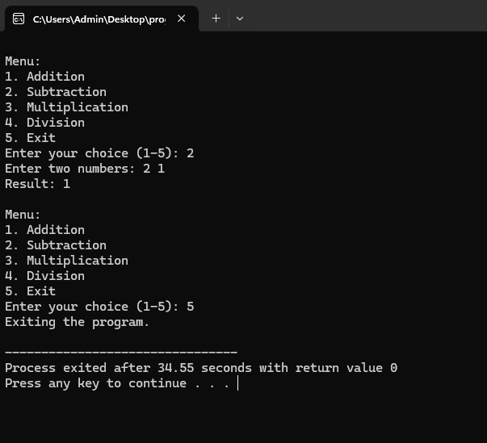

Question5:
#include <stdio.h>
int main(){
int num,org,rev,r;
printf("enter a number:");
scanf("%d",&num);
org=num;
while(num>0){
r=num%10;
rev=rev*10+r;
num/=10;
}if (org==rev){
printf("it is a palindrome.");
}else{
printf("it is not a palindrome.");
}return 0;
}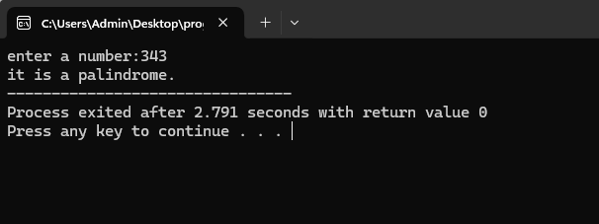
Question6:
#include <stdio.h>
#include <math.h>
int main() {
int num, originalNum, remainder, result = 0, n = 0;
printf("Enter an integer: ");
scanf("%d", &num);
originalNum = num;
while (originalNum != 0) {
originalNum /= 10;
n++;
}
originalNum = num;
while (originalNum != 0) {
remainder = originalNum % 10;
result += pow(remainder, n);
originalNum /= 10;
}
if (result == num) {
printf("%d is an Armstrong number.\n", num);
} else {
printf("%d is not an Armstrong number.\n", num);
}
return 0;
}
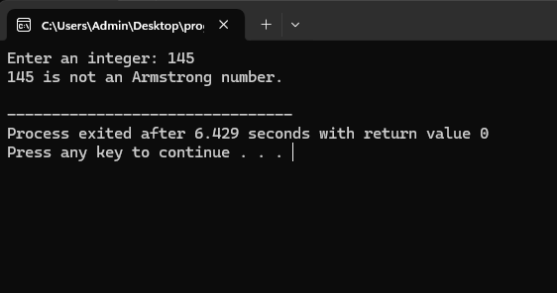
Question 7:
#include <stdio.h>
int main() {
int a_ap, d_ap, n_ap;
int a_gp, r_gp, n_gp;
int i;
printf("--- Arithmetic Progression ---\n");
printf("Enter the first term (a): ");
scanf("%d", &a_ap);
printf("Enter the common difference (d): ");
scanf("%d", &d_ap);
printf("Enter the number of terms (n): ");
scanf("%d", &n_ap);
printf("AP Series: ");
int current_term_ap = a_ap;
for (i = 0; i < n_ap; i++) {
printf("%d ", current_term_ap);
current_term_ap = current_term_ap + d_ap;
}
printf("\n\n");
printf("--- Geometric Progression ---\n");
printf("Enter the first term (a): ");
scanf("%d", &a_gp);
printf("Enter the common ratio (r): ");
scanf("%d", &r_gp);
printf("Enter the number of terms (n): ");
scanf("%d", &n_gp);

printf("GP Series: ");
int current_term_gp = a_gp;
for (i = 0; i < n_gp; i++) {
printf("%d ", current_term_gp);
current_term_gp = current_term_gp * r_gp;
}
printf("\n");
return 0;
}
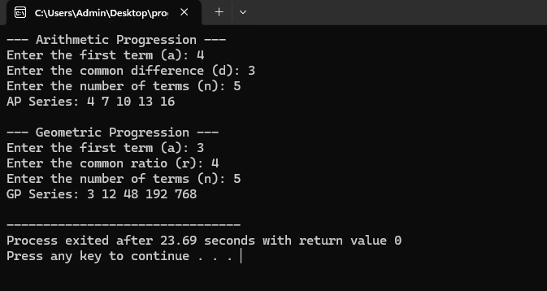
Question 8:
#include <stdio.h>
int main(){
int n = 5;
for (int i = n; i >= 1; i--){
for (int j = 1; j <= i; j++){
printf("*");
}printf("\n");}
return 0;
}

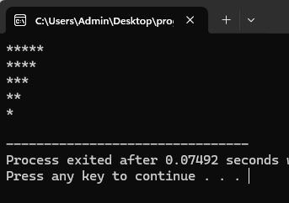
#include <stdio.h>
int main() {
int n = 5, count = 1;
for (int i = 1; i<= n; i++){
for (int j = 1; j <= i; j++){
printf("%d ", count);
count++;
} printf("\n");
}return 0;
}
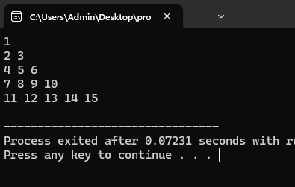
#include <stdio.h>
int main() {
int rows = 5;
for (int i = rows; i >= 1; i--) {
for (int j = 1; j <= i; j++) {
printf("*");
}printf("\n");
}return 0;
}
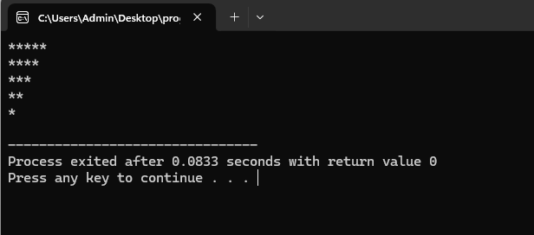
#include <stdio.h>
int main(){
int rows = 5;
for (int i = 1; i <= rows; i++) {
for (int j = i; j < rows; j++) {
printf(" ");
}
for (int j = 1; j <= (2 * i - 1); j++) {
printf("*");
}printf("\n");
}return 0;
}
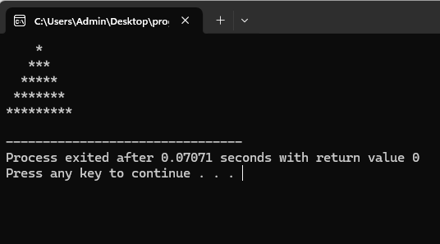
#include <stdio.h>
int main() {
int rows = 5;
for (int i = 1; i <= rows; i++) {
for (int j = 1; j <= i; j++) {
printf("*");
}printf("\n");
}return 0;
}
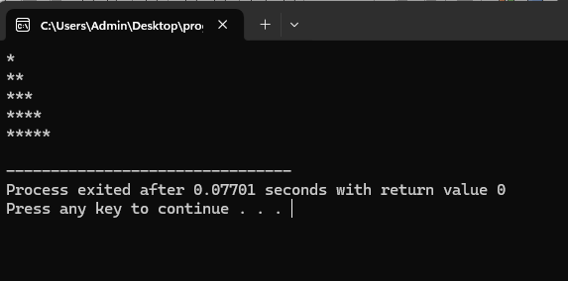
#include<stdio.h>
int main() {
int n = 5;
for (int i = 1; i <= n; i++) {
for (int j = 1; j <= i; j++) {
printf("%d ", j);
}printf("\n");
}return 0;
}
